

**‘’Indoor plant as a source of recreation and income’’**

**A Term Paper**

**Submitted to the East West University, Aftabnagar, Dhaka**

**English Department.**

**Supervised by:**

Syeda Shabnam Mahmud

Assistant Professor

Department of English

East West University.

**Submitted by:**

1. Name : Anika Mobashera

Depertment : Computer Science and Engineering

Roll : 2021-1-60-130

1. Name : Jannatul Ferdous Anika Sheikh

Depertment : Electrical and Electronics Engineering

Roll : 2020-2-80-027

1. Name: Nazat Amin Khan (C)

Roll: 2020-2-22-024

Department: Civil Engineering

**Date of Submission- 8 September , 2021**

**Table of Contents**

**‘’Indoor plant as a source of recreation and income’’**

|  |  |
| --- | --- |
| **Particulars** | Page no. |
| **𝘈𝘣𝘴𝘵𝘳𝘢𝘤𝘵** | **1** |
| **‌𝘐𝘯𝘵𝘳𝘰𝘥𝘶𝘤𝘵𝘪𝘰𝘯** | **1** |
| **‌𝘙𝘢𝘵𝘪𝘰𝘯𝘢𝘭𝘦** | **2** |
| **‌𝘙𝘦𝘴𝘦𝘢𝘳𝘤𝘩 𝘘𝘶𝘦𝘴𝘵𝘪𝘰𝘯** | **2** |
| **‌𝘊𝘩𝘢𝘱𝘵𝘦𝘳 1** | **3** |
| **Chapter 2** | **4** |
| **‌𝘓𝘪𝘵𝘦𝘳𝘢𝘵𝘶𝘳𝘦 𝘙𝘦𝘷𝘪𝘦𝘸** | **5** |
| **‌𝘍𝘪𝘯𝘥𝘪𝘯𝘨𝘴** | **6 -11** |
| **Interview Answer** | **12** |
| **‌𝘓𝘪𝘮𝘪𝘵𝘢𝘵𝘪𝘰𝘯** | **13** |
| **‌𝘙𝘦𝘤𝘰𝘮𝘮𝘦𝘯𝘥𝘢𝘵𝘪𝘰𝘯** | **14** |
| **‌𝘊𝘰𝘯𝘤𝘭𝘶𝘴𝘪𝘰𝘯** | **15** |
| **‌𝘙𝘦𝘧𝘦𝘳𝘦𝘯𝘤𝘦** | **16-17** |
| **‌𝘈𝘱𝘱𝘦𝘯𝘥𝘪𝘹** | **18-19** |

**Abstract**

Mother nature has been our biggest supporter in life, whether it is for one’s health or wealth. Indoor plantation comes first as a hobby for many. However, it has also become a growing source of income. Recently, the COVID-19 pandemic has experienced an upward trend in many types of online business, where indoor plantation is one of the top.

**Introduction**

An indoor plantation is a kind of plantation that is cultivated by people indoors in places such as residences, offices, and rooftops. People do this as a hobby, to keep themselves busy, as a medium of recreation and as a purpose of income. Interaction with indoor plants reduces psychological stress and suppresses autonomic nervous system activity in young adults. As development in information technology causes a great deal of stress to modern people, controlling this stress has now become an important issue. For this reason, this research aimed to test the physiological benefits of interaction with indoor plants. Indoor plants can play an important role in providing a higher quality living environment. Since a working environment that provides comfortable conditions for everyone to do their work optimally is a fundamental requirement for a healthy work environment, Moreover, relevant research shows that plants are used not only to bring several aesthetic as well as psychological benefits, better air quality, and higher work productivity to the indoor environment, but also to improve the climate and decoration outside the buildings. If the purpose is income, one should follow every step to protect their plant kingdom, work hard and utilize their knowledge. Another way of earning is through digital marketing, where people can sell plants in online stores such as Facebook marketplace. Nowadays, it has become the largest path to creating income resources. This is how people can earn a good amount of money. Homesick people and housewives are the main ones to introduce this new era of earning.

Page 1

**Rationale**

Online enterprises currently exist in practically every industry. Humanity has been experimenting with a new version of the universe in which the internet unites us. Especially since the discovery of Covid-19. Indoor plantation fields have snatched up a sizable chunk of the market. During quarantine, unemployment was a problem, but the indoor planter company is a novel solution. Throughout the epidemic, quarantine has risen, but indoor plantation has become a lifeline.

**Research Question**

The interviews with open-ended questions were designed to know why and how they managed to start an indoor plantation. The main questions we focused on are given below.

1. **How can indoor plants reduce psychological stress and can work as a source of recreation?**

**2. ‌How can anybody profit economically from indoor plants?**

Page 2

**Chapter 1 : Source Of Recreation**

Indoor plantation has evolved into a high-quality form of recreation as well as a source of money in recent years. For decades, scientists have examined the connection between nature and human well-being. Numerous studies have found that engaging with nature in some way can help people reduce stress, lower blood pressure, heal faster, and be happier. Even those who work in an urban office environment may benefit from a few glimpses of greenery. Observing trees from a high-rise window or having potted plants at your desk can boost job happiness and communication. Rooms with plants have less dust and mold than rooms without any vegetation, according to researchers. Allergens and other airborne particles are caught by the leaves and other components of the plants, which act as natural filters. Low-light houseplants such as the Chinese evergreen or the peace lily will suffice. Violets, as well as other plants with textured leaves, could be even more effective trappers. Pollen or spore-producing plants should be avoided. Furnaces and air conditioners, especially in the winter, can deplete indoor humidity. This can make you more susceptible to contracting a cold or the flu, as well as itch your skin. Houseplants help to keep the air wet. According to one study, a collection of spider plants increased the relative humidity in a bedroom from 20% to a more comfortable 30%.The use of technology in our everyday lives is acknowledged to have produced a significant deal of stress in the modern world, and many people find it difficult to manage the tension that comes with it. The researchers wanted to see if there were any psychological benefits to interacting with indoor plants. For millennia, people have brought plants into their homes and other indoor settings, but little is known about their psychological impacts. The experimental research on the psychological advantages of indoor plants is critically reviewed in this article. Rather than the impacts of guided interactions with plants in horticulture treatment or the indirect effect of indoor plants as air purifiers or humidifiers, we focus on the benefits received through passive interactions with indoor plants. Emotional states, pain perception, inventiveness, task performance, and autonomic arousal indices were all studied in the experiments that were reviewed. Some discoveries, such as e, reoccur

Page 3

**Chapter 2 : Indoor plantation as income resource**

Money plants may be a fiction, but we are aware that there are a variety of alternative ways for plants to have money flowing in. It is rewarding to work as a gardener. Plants do a lot more than just make money, so it’s not always just monetary. They are aesthetically beautiful, have a long-term good impact on mental and physical well-being, and have unrivalled ornamental value. People can earn money by growing indoor plants, and many do so while pursuing their pastime.Taking up indoor gardening as a side gig can be a great idea at times, especially when we are short on cash. If one can learn the ropes of the trade, he can eventually make it your full-time job. Plants and plant items can be sold on Amazon and other online stores. If people can maintain their own websites, selling indoor plants for money could be a viable option. Alternatively, a person can sell items at his neighbourhood market. If he is unable to pursue any of the other choices, plants can be sold from the convenience of his own home. People with good marketing and communication skills will be needed to ensure that everyone in their local neighbourhood is aware of the business, as they will make up the majority of the clientele.

Page 4

**LITERATURE REVIEW:**

Literature reviews are secondary sources and do not report new or original experimental work. Most often associated with academic-oriented literature, such reviews are found in academic journals and are not to be confused with book reviews, which may also appear in the same publication. Literary practice is now part of the work of any academy or any other kind of work. Literary matter is inherent in any work we do. Through a narrow-scope literature review may be included as part of a pre-reviewed journal article presenting new research, serving to situate the current study within the body of the relevant literature and to provide context for the reader. Psychological restoration in the environmental psychology field is the recovery of deleted resources which can be psychology. This results from interaction with a restorative environment to change negative states to positive one. Plants and our lives are closely intertwined. There will always be a bridge between us and the environment if we are involved in this tree planting.

Page 5

**Findings and discussion:**

To find out the people opinion based on online marketing we did a survey by google form among the 25 people, the results are given below:

1. 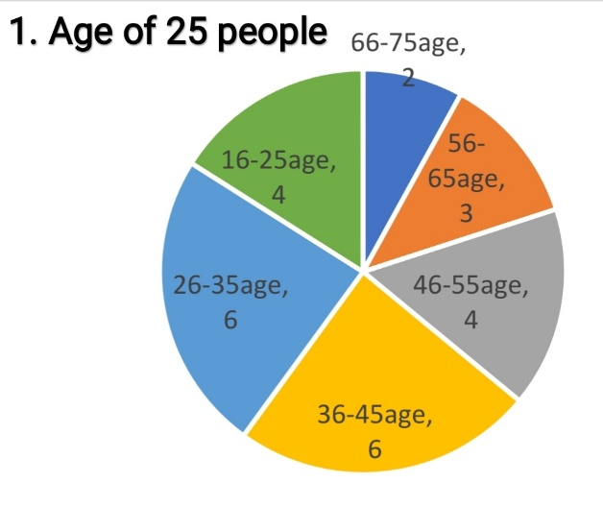From chart 1 we came to know the age of 25 people.
2. 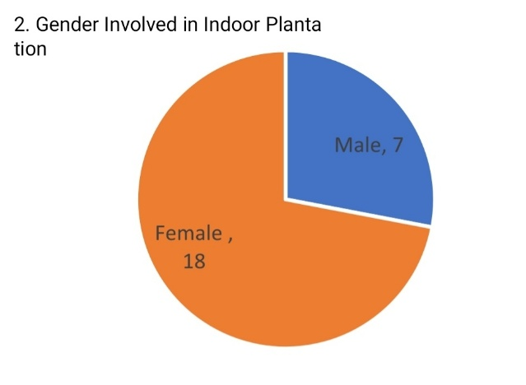From chart 2 we came to know the gender of 25 people. The majority is female. So that, we can say, female are mostly interested in plantation.

Page 6

1. 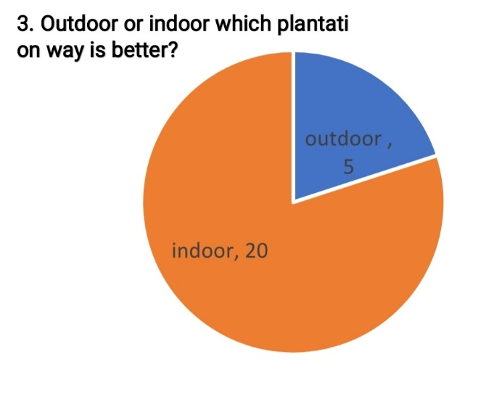From chart 3 we can see the people's preference about plantation. Most of the people things that indoor plantation is better than outdoor plantation.
2. 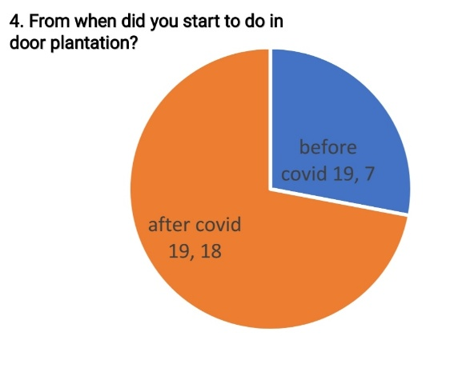In chart 4 we came to know that when they started indoor plantation. The majority started after covid pandemic

Page 7

1. From chart 5, we came to know do they face space problem or not. Most of the people is facing space problem.

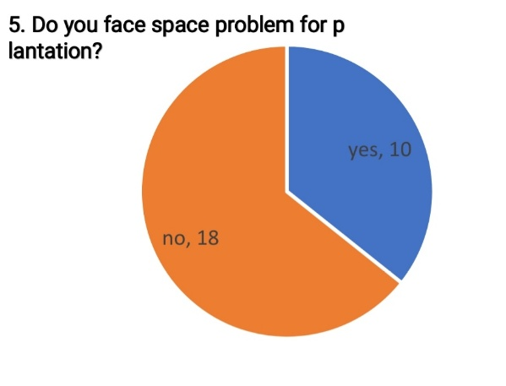

1. In chart 6, people think that indoor plantation increased after covid-19.

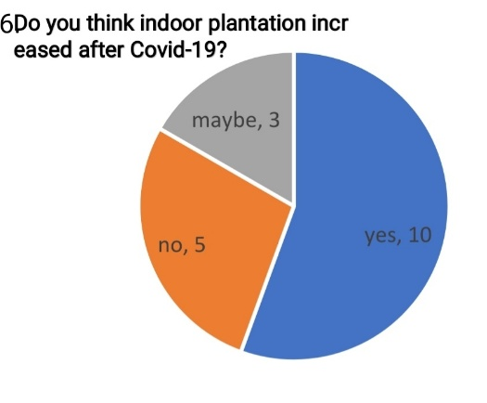

Page 8

1. From chart 7, we found mix opinion about indoor plantations popularity after covid-19

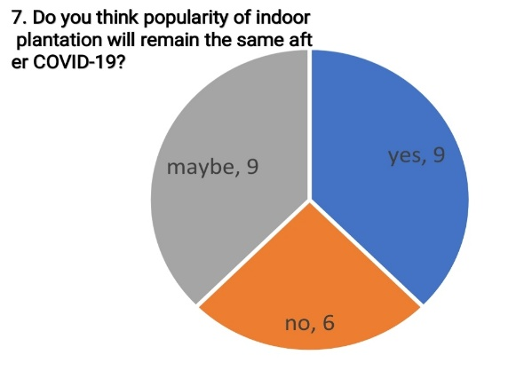

1. We asked people about their family support for indoor plantation. We found positive response about it. We showed it in chart below.

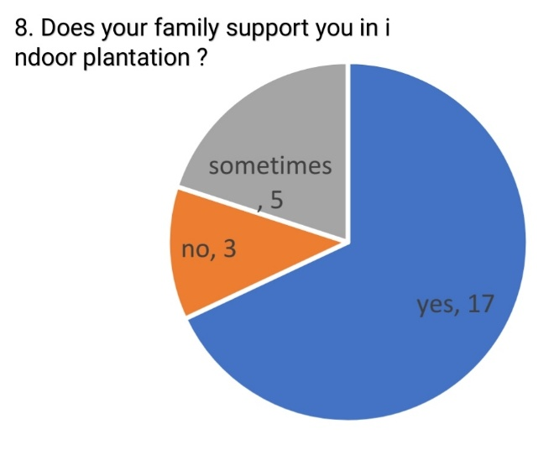

Page 9

1. In pie chart 9, we came to about the maintains cost of indoor plantation. Most of the people think it is not costly. At the same time a large number of people think it is medium costly.

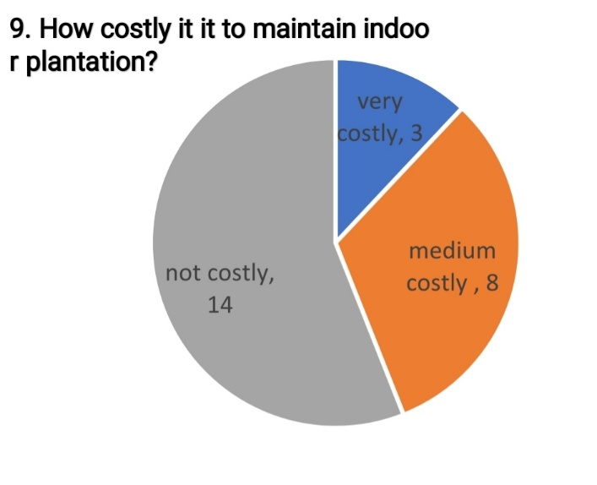

1. 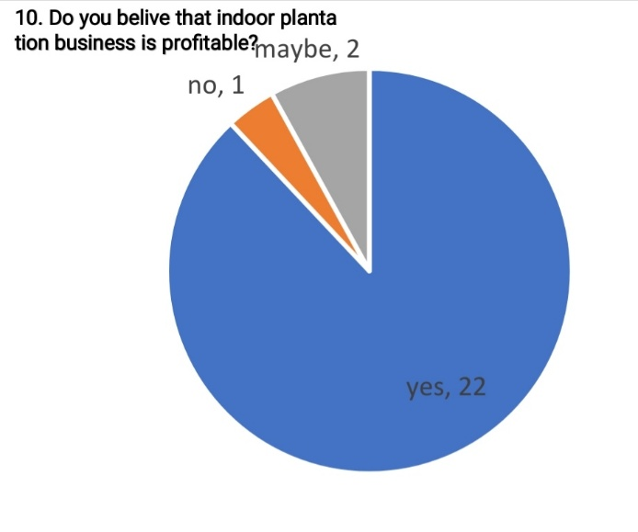In chart 10 we can see that, out of 25 people 22 people believe that indoor plantation is a profitable business.

Page 10

1. 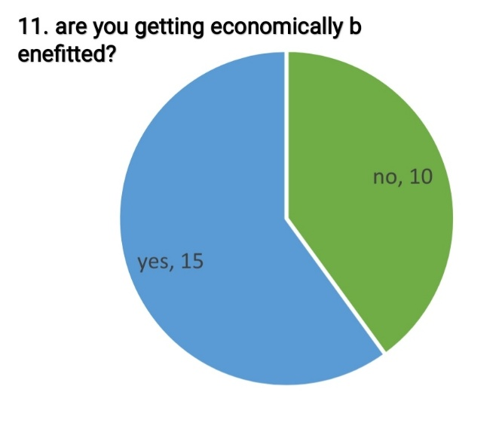 In this chart, wee asked people if they are getting economic benefit by indoor or not. Here surprisingly we found 10 people out of 25 people said they aren’t getting economic benefit. After that when we researched, we came to know they aren’t involved with indoor plantation business. Because they do indoor plantation as a hobby and mental satisfaction. Still we found large amount of people is doing indoor plantation for recreation and also as a purpose of income

Page 11

**Interview Answer**

**Interview participants :**

Name : Nazma Begum

Age 55

Profession : House wife and planta seller

Location : Tejgaon, Dhaka

Drive link below-

(https://drive.google.com/folderview?id=1dKxMLkkc5EpDSILjqmL1mftuB21JxGDP)

Page 12

**Limitations:**

Regarding information collection for this research, researchers had to face some limitations, which may affect the study a little bit. Plants and our lives are closely intertwined. There will always be a bridge between us and the environment if we are involved in this tree planting.Researching these things takes a lot of time, which wastes some time studying and other work. First of all, the time limitation, researchers did not have enough time to research properly. Secondly, the lack of proper information was one of the major limitations researcher’s faced. This is corona pandemic time. For this reason we weren't able to work on the field. Also we weren't able to collect data and take interviews by visiting any place

Page 13

**RECOMMENDATIONS:**

Researcher’s of this study has recommended that the next researcher to research this issue. For better research, they recommend the next researcher to research more people and collect the information in a mixed-method then it will show a more effective result. As researchers did not research an adequate number of people and other issues which are related to the study, whoever will work next on indoor plantation should keep these in mind. They need to be aware of their previous problems and they should also think a better way for it. Also they should make it more easier to the next generation so that everyone can find interesting on indoor tree plantations.

Page 14

**Conclusion:**

In conclusion, it has been observed that indoor plantation can be beneficial in many ways. It is good for the environment and also a great recreation source. It reduces psychological stress and increase physiological benefits. Furthermore, the study results indicated that indoor plants not only fulfil our hobbies but also provide a source of income for our living. Everyone can earn money by doing indoor plantation. By doing indoor plantation, we will get a great outlook on our interior. In fact, our results provide evidence of the impact of indoor plantation on households’ income through a field survey for a short time with some native species. Therefore, it can be said that indoor plants are a source of recreation and income.

Page 15

**Reference List:**

Article link -

1. <https://scholar.google.com/scholar?hl=en&as_sdt=0%2C5&q=indoor+plants+for+recreation&btnG=#:~:text=Chang%2C%20Chen-Yen%2C%20and%20Ping-Kun%20Chen.%20%22Human%20response%20to%20window%20views%20and%20indoor%20plants%20in%20the%20workplace.%22%20HortScience%2040.5%20(2005)%3A%201354-1359>.
2. <https://scholar.google.com/scholar?cluster=10785513035961987999&hl=en&as_sdt=0,5&scioq=indoor+plants++#:~:text=Bringslimark%2C%20Tina%2C%20Terry%20Hartig%2C%20and%20Grete%20G.%20Patil.%20%22The%20psychological%20benefits%20of%20indoor%20plants%3A%20A%20critical%20review%20of%20the%20experimental%20literature.%22%20Journal%20of%20Environmental%20Psychology%2029.4%20(2009)%3A%20422-433>.
3. <https://scholar.google.com/scholar?hl=en&as_sdt=0%2C5&q=indoor+plants+for+income+sources&oq=indoor+plants+for+income+source#:~:text=MLA-,Usavagovitwong%2C%20Nattawut.%20%22IMPROVING%20INDOOR%20ENVIRONMENTS%20FOR%20LOW-INCOME%20SETTLEMENTS.%22%20(2003).,-APA>
4. Indoor Plantation with Hydroponics: A Reddit Community Analysis to Identify Knowledge Gaps

Authors: [Elisa Solis-Topanga](https://journals.ashs.org/horttech/search?f_0=author&q_0=Elisa+Solis-Toapanta)[1](https://journals.ashs.org/horttech/view/journals/horttech/30/3/article-p346.xml#affiliation0), [Andrei Kirilenko](https://journals.ashs.org/horttech/search?f_0=author&q_0=Andrei+Kirilenko)[2](https://journals.ashs.org/horttech/view/journals/horttech/30/3/article-p346.xml#affiliation1), and [Celina Gómez](https://journals.ashs.org/horttech/search?f_0=author&q_0=Celina+G%C3%B3mez)[1](https://journals.ashs.org/horttech/view/journals/horttech/30/3/article-p346.xml#affiliation0)

Link:<https://doi.org/10.21273/HORTTECH04574-20>

### **Indoor Plantation is a Great Experience**

**Len Calderone for |**Aggrotech

02/08/18, 10:14 AM | [Indoor & Vertical Farming](https://www.agritechtomorrow.com/category/planning-preparation), [Monitoring & Growing](https://www.agritechtomorrow.com/category/monitoring-growing) | [Len Calderone - Contributing Author](https://www.agritechtomorrow.com/company_directory/len-calderone--contributing-author/199986373) | [indoor](https://www.agritechtomorrow.com/tag/indoor)

1. Indoor Plantation

Submitted By rukia214  
Words 4425  
Pages 18

# The influence of plants on productivity: A critical assessment of research findings and test methods

July 2010

Author:

* Iris Bakker
* [Theo J M Van der Vorst](https://www.researchgate.net/profile/Theo_Van_der_Voordt2)

Page 16

# A Case Study of Indoor Garden-Based Learning with Hydroponics and Aquaponics: Evaluating Pro-Environmental Knowledge, Perception, and Behavior Change

* December 2015
* [Applied Environmental Education and Communication An International Journal](https://www.researchgate.net/journal/1533-015X_Applied_Environmental_Education_and_Communication_An_International_Journal) 14(4):256-265

**Author:**

* [**Andrew Schneller**](https://www.researchgate.net/profile/Andrew_Schneller)

Page 17

**Appendix**

Name-

Age-

Sex-

1) Outdoor or indoor which plantation way is better?

A. Outdoor B.Indoor

2) From when did you start to do indoor plantation?

A. Before covid andemic B. After covid pandemic

3) Do you face space problem for plantation?

A. Yes B.No

4) Do you think indoor plantation increased after Covid-19?

A.Yes B.NO C. Maybe

5) Do you think popularity of indoor plantation will remain the same after COVID-19?

A.Yes B.No C.Maybe

6) Does your family support you in indoor plantation ?

A. Yes ,a lot B. No C. Sometimes

7) Does indoor plantation helps you to boost your productivity?

A.Yes B. No C. Maybe

8) Does indoor plans helps to reduce stress?

A. Yes B. Maybe C. No

9) How costly it it to maintain indoor plantation?

a)Very costly b) medium costly c) not much

10) Are indoor plants expensive?

A. Yes B. No C. Avarage

11) Do you belive that indoor plantation business is profitable?

A. Yes B.No C.Maybe

12) are you getting economically benefitted?

Page 18

A. Yes B.No

14) Your future plan about indoor plantation?

Ans:

Page 19